Gateway Determination
Planning proposal (Department Ref: PP-2023-404): to reclassify and rezone part of 2 Rose Street, Campbelltown & Kanbyugal Reserve and to apply corresponding development controls.
I, the Director, Western District at the Department of Planning and Environment, as delegate of the Minister for Planning and Public Spaces, have determined under section 3.34(2) of the Environmental Planning and Assessment Act 1979 (the Act) that an amendment to the Campbelltown Local Environmental Plan 2015 to reclassify and rezone part of 2 Rose Street, Campbelltown & Kanbyugal Reserve and to apply corresponding development controls should proceed subject to the following conditions:
- Prior to community consultation, the planning proposal is to be updated to:
  - Clarify that the planning proposal does not involve a subdivision or any other lot boundary adjustments and that the proposed rezoning and reclassification apply to part lots.
  - Explain how the Animal Care Facility is a permissible use under the incoming E4 General Industrial zone for clarity.
  - Update all references to the IN2 Light Industrial zone to refer to the incoming E4 General Industrial zone.
  - Clarify whether the land is subject to any public reserve status and whether it is proposed to extinguish this as part of the planning proposal.
  - Identify the subject site on all maps within the planning proposal and ensure maps in the planning proposal document are a legible scale.
  - Address Section 9.1 Ministerial Directions 3.7 Public Bushland, 3.10 Water Catchment Protection, and 4.1 Flooding.
  - Provide a copy of the Local Planning Panel advice as a supporting document.
- Public exhibition is required under section 3.34(2)(c) and clause 4 of Schedule 1 to the Act as follows:
- the planning proposal is categorised as standard as described in the Local Environmental Plan Making Guidelines (Department of Planning and Environment, 2021) and must be made publicly available for a minimum of 20 working days; and
- the planning proposal authority must comply with the notice requirements for public exhibition of planning proposals and the specifications for material that must be made publicly available along with planning proposals as identified in Local Environmental Plan Making Guidelines (Department of Planning and Environment, 2021).
- Consultation is required with the following public authorities and government agencies under section 3.34(2)(d) of the Act and/or to comply with the requirements of applicable directions of the Minister under section 9 of the EP&A Act:
- NSW Rural Fire Service

Each public authority is to be provided with a copy of the planning proposal and any relevant supporting material via the NSW Planning Portal and given at least 30 working days to comment on the proposal.
- A public hearing is not required to be held into the matter by any person or body under section 3.34(2)(e) of the EP&A Act. This does not discharge Council from any obligation it may otherwise have to conduct a public hearing.
- A public hearing is required to be held in accordance with Section 29 of the Local Government Act 1993 and the Department’s Practice Note PN 16-001.
- Given the nature of the proposal, Council is not authorised to be the local plan-making authority.
- The LEP should be completed on or before 5 March 2024.

Dated 14 day of May 2023.

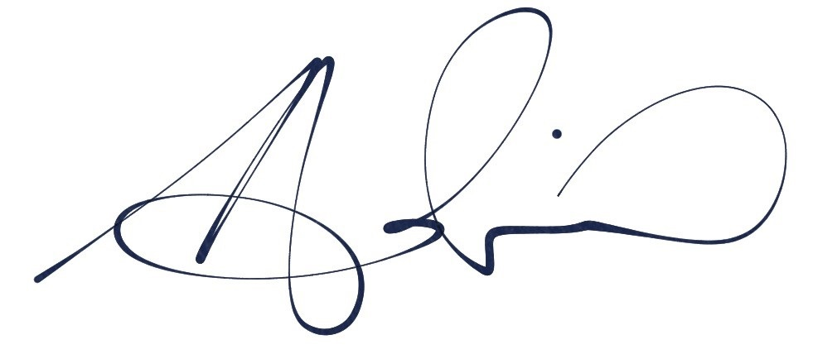
Adrian Hohenzollern
Director, Western District
Planning and Land Use Strategy
Department of Planning and Environment

Delegate of the Minister for Planning and Public Spaces

